English for Informatics 1: Sixth Edition

UNIT 4
Networking


Picture 4.1

Learning Outcomes:

By the end of the lesson, the students are expected to be able to use appropriate English to:
- identify and explain kinds of network hardware and its function

- explain the definition of network and its hardware components

- explain kinds of network topography

- identify and make sentences using if-clause type 1

P a g e | 30
English for Informatics 1: Sixth Edition

1.1 Explaining a network and network hardware

Exercise 1: Below are hardware components used in creating a network. Match the words 1-8 to the descriptions a-g.

1. | A modem | a. | is an entrance to another network
2. | A repeater | b. | channels incoming data but maintains the bandwidth speed.
3. | A bridge | c. | allows wireless devices to connect to the network
4. | A router | d. | modulates and demodulates the data into a digital or an analog
5. | A gateway |  | signal
6. | A switch | e. | channels incoming data but shares the bandwidth among the
7. | A hub |  | devices present on a network
8. | A wireless access | f. | sends the digital signal further on in the network
 | point | g. | connects networks and sends packages of data between them
 |  | h. | connects networks that use the same protocol


Exercise 2: Look at the sample of a Local Area Network (LAN). Then, answer the following questions.
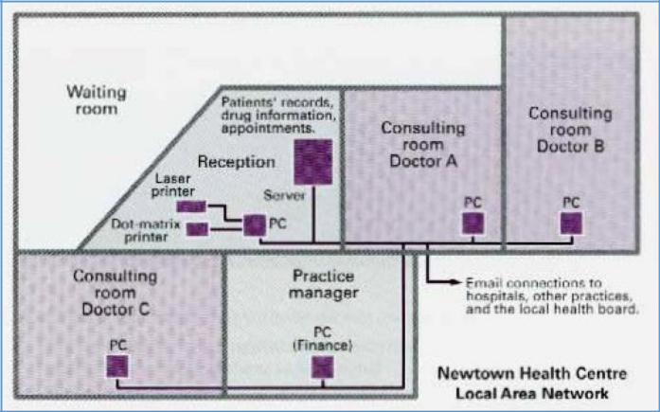

- Who are the users?

- What kind of hardware is used?

- What do the doctors use it for?

- What do the receptionists use it for?

- What does the practice manager use it for?

P a g e | 31
English for Informatics 1: Sixth Edition

Exercise 3: With the help of this diagram, answer the following questions.
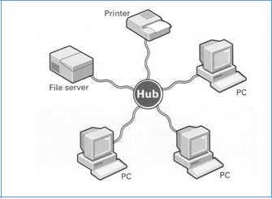

Picture 4.3

- What is a network?

- What are its hardware components?

- What is the difference between a local area network and wide area network?

- What advantages do you think networks have?

Exercise 4: Read the following text to check your answer.


What is a network?

A network is simply two or more computer linked together. It allows users to share not only data files and software applications, but also hardware like printers and other computer resources such as fax.

Most networks link computers within a limited area – within a department, an office, or a building. These are called Local Area Networks, or LANs. But networks can link computers across the world, so you can share information with someone on the other side of the world as easily as sharing with a person at the next desk. When networks are linked together in this way, they are called Wide Area Networks, or WANs.

Networks increase productivity by allowing workers to share information easily without printing, copying, telephoning, or posting. They also save money by sharing peripherals such as printers.

Basic English for Computing, (2012: 46)

P a g e | 32
English for Informatics 1: Sixth Edition

Exercise 5: With the help of the diagram on exercise 3 above, identify these hardware components of the network.

1. |  | Most networks have at least one central computer which all
 |  | desktop computers connect to. This is the most important
 | ___________ | computer on your network. It stores the data files and
 |  | application software program that the users need to access or
 |  | share with others.
2. |  | This is the desktop computer or notebook computer on your
 | ___________ | desk. It is linked to the server, and can access files and
 |  | applications on it.
3. | ___________ | Each computer on the network has a device called a network
 |  | interface card which connects to the computer to the
 |  | network. Many computers come with these cards fitted as
 |  | standard.
4. |  | Once you have a network you can share any number of
 | ___________ | these, including printers, scanners, CD-ROM drives, and
 |  | back-up devices.
5. |  | Desktops typically connect via telephone-type cabling to this
 | ___________ | intermediary service, which enables communication between
 |  | server and desktops.

Exercise 6: Read Katharina’s email to Agatha. Complete this email with the words in the box.

equipment | internet | LAN | recommend
remote | should | VPN | WAN

P a g e | 33
English for Informatics 1: Sixth Edition
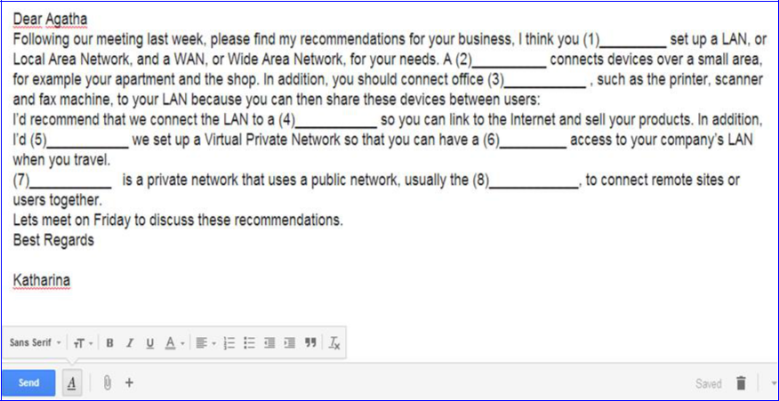

1.2 Identifying Network Topologies

Exercise 7: This following diagrams show four network topologies. Match each with the

correct name.

ring bus star mesh
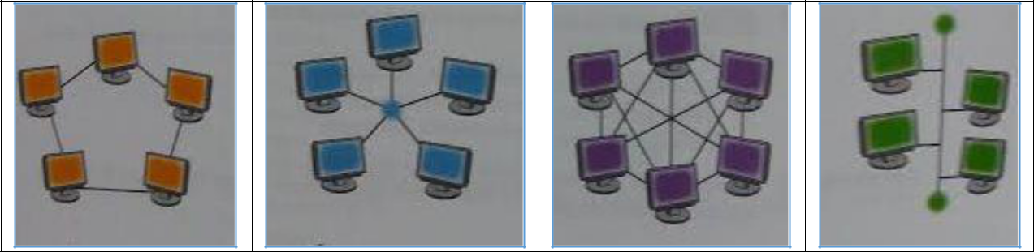

1. | 2. | 3. | 4.

Picture 4.3

P a g e | 34
English for Informatics 1: Sixth Edition

Exercise 8: Read this following text to check your answer for exercise 7.

NETWORK TOPOLOGY

Topology refers to the shape of a network. There are three basic physical topologies. One is a star system. In this topology, there is a central device to which all the computers/workstations are directly connected. This central position can be occupied by a server, or a hub, a connection point of the elements of a network that redistributes the data. Another type is a ring system. This is a network that has each workstation linked to two others. In a bus system there is a central or main cable which is called a bus, and each workstation is linked to it. There are also mixed topologies, like the tree, a group of stars connected to a central bus. Some large networks use a mesh. In this topology, each workstation is linked to several others. This has one big advantage: if one connection breaks, the data can use other connections. Therefore, it is difficult to break a mesh

network.

Exercise 9: Refering to exercise 7 and 8 above. Identify which topologies these statements refer to.

- If one of the computer fails, the whole network will be affected.

- If we remove a computer from the network, it won’t affect the other computers.

- If the main cable fails, the whole network will fail.

- If the central server fails, the whole network will fail.

- If a cable breaks, the whole network will be affected.

- If a computer fails, it won’t affect the other computers.

P a g e | 35
English for Informatics 1: Sixth Edition

Exercise 10: Refering to exercise 9. You see that If-Clause Type 1 are used the the sentences above. Here are more explanation on the If-Clause Type 1.

 | Note |  |  | Description |  |  |  |  | Examples
 | Formula |  |  | If + simple present, | simple future
 |  |  |  | If clause (condition), | Main clause
 |  |  |  | (result)
 |  |  |  | Meaning:
 |  |  |  | If this thing happens, that thing will |  |  |  | ▪ | If the main cable fails, the
 |  |  |  | happen. |  |  |  | ▪ | If the main cable fails, the
 |  |  |  | happen. |  |  |  |  | whole network will fail.
The Order |  |  |  | The order of the clauses is not fixed. |  |  |  |  | whole network will fail.
 |  |  |  |  |  |  |  | ▪ | The whole network will fail if
 |  |  |  | When you change the order of the |  |  |  | ▪ | The whole network will fail if
 |  |  |  |  |  |  |  |  | the main cable fails.
 |  |  |  | clauses, you need to pay attention to |  |  |  |  | the main cable fails.
 |  |  |  |  |  |  |  | ▪ | If a cable breaks, the whole
 |  |  |  | the punctuation and pronoun, but the |  |  |  | ▪ | If a cable breaks, the whole
 |  |  |  |  |  |  |  |  | network will be affected.
 |  |  |  | meaning is identical. |  |  |  |  | network will be affected.
 |  |  |  | meaning is identical. |  |  |  | ▪ | The whole network will be
 | Function |  |  | These sentences are based on facts, |  |  |  | ▪ | The whole network will be
 | Function |  |  |  |  |  |  |  | affected if a cable breaks.
 |  |  |  | and they are used to make |  |  |  |  | affected if a cable breaks.
 |  |  |  | statements about the real world, and
 |  |  |  | about particular situations. In type 1
 |  |  |  | conditional sentences, the time is
 |  |  |  | the present or future and the
 |  |  |  | situation is real.
If-Clause |  |  |  | In type 1 conditional sentences, you |  |  | ▪ |  | If a computer fails, it won’t
Type 1 with |  |  |  | can also use modals in the main |  |  |  |  | affect the other computers.
Modals |  |  |  | clause instead of the future tense to |  |  | ▪ |  | It won’t affect the other
 |  |  |  | express the degree of certainty, |  |  |  |  | computers if a computer fails.
 |  |  |  | permission, or a recommendation
 |  |  |  | about the outcome.

P a g e | 36
English for Informatics 1: Sixth Edition

Exercise 11: Refering to the If-Clause Type 1 that you learned, complete the following sentences.

- If she (need) ___________ a computer, her brother (give) ___________ her his computer.

- If she (read/not) ___________ the Computer Networking module and her notes, she (pass/not) ___________ the test.

- If they (invite/not) ___________ me to the computer workshop, I (go/not)

___________.

- The administration staff (accept) ___________ his thesis draft if Rama (turn in)

___________ his thesis draft on time.

- If you (want) ___________ a remote access to your company’s LAN, you (set up)

___________ a Virtual Private Network.

- If Anugrah (need) ___________ to connect devices over a small area, he (need)

___________ to set up a LAN.

Exercise 12: Link each action (1-10) with a suitable consequence (a-j). Then, combine

them using if-clause.

Example: If you place a floppy disk near magnet, you will destroy the data.


1. | You place a floppy disk near a |  | a. | The cursor moves to the left
 | magnet |  | b. | The computer hangs
2. | You press print screen |  | c. | It is not lost when you switch off
3. | You input the correct password |  | d. | You damage the drive
4. | You add memory to a computer |  | e. | You copy the screen
5. | You move the mouse to the left |  | f. | You have access to the network
6. | You store data in RAM |  | g. | You destroy the data
7. | You use a faster modem |  | h. | It runs faster
8. | There is a memory fault |  | i. | Your phone bills are lower
9. | You press the arrow key |  | j. | The cursor moves accross the screen

- You move a CD-ROM drive with the disk in place

Exercise 13: Now make a short dialog that uses the If-Clause Type 1 that you learned.

Perform the dialog in front of the class.

P a g e | 37

